**Homework 1**

**Question 1 : How does natural neuron work?**

**Answer :**

Natural neurons, or biological neurons, transmit signals through a process involving electrical and chemical signals. When a neuron receives a stimulus, it generates an action potential—an electrical impulse that travels down the axon. At the axon terminal, neurotransmitters are released into the synapse, binding to receptors on the next neuron's dendrites. This binding can either excite or inhibit the receiving neuron, influencing whether it generates its own action potential and continues the signal transmission. The process enables communication within neural networks, supporting various functions in the nervous system.

**Question 2 : How does natural neuron transmit signal to other neurons?**

**Answer :**

Natural neurons transmit signals to other neurons through a process called synaptic transmission. When an action potential is generated in a neuron, it travels down the axon and reaches the axon terminal. Neurotransmitters are then released into the synapse, where they bind to receptors on the dendrites of the next neuron. This binding can either excite or inhibit the receiving neuron, influencing whether it generates its own action potential and continues the transmission of the signal. This electrochemical process enables communication within neural networks in the nervous system.

**Question 3 : Describe the McCulloch and Pitts model of artificial neuron?**

**Answer :**

The McCulloch and Pitts model, proposed by Warren McCulloch and Walter Pitts in 1943, is a foundational concept in artificial neural networks. This model provides a simplified representation of how a biological neuron works and serves as the basis for early developments in artificial intelligence. Here are the key components and principles of the McCulloch and Pitts artificial neuron model:

1. **Binary Threshold Model:**

The model simplifies the continuous nature of biological neurons by using a binary threshold model. Neurons are either "on" or "off" based on a threshold.

1. **Inputs and Outputs:**

The artificial neuron receives multiple binary inputs (either 0 or 1) from other neurons or external sources. These inputs are weighted to represent their significance in influencing the neuron's output.

1. **Weighted Sum:**

Each input is multiplied by a corresponding weight, reflecting the strength of the connection. The weights determine the importance of each input in the neuron's decision-making process.

1. **Threshold Activation:**

The weighted sum of inputs is then compared to a predefined threshold. If the sum exceeds the threshold, the artificial neuron produces an output (1 or "on"). Otherwise, it remains inactive (0 or "off").

1. **Boolean Logic:**

The model is based on boolean logic operations. It can perform logical operations such as AND, OR, and NOT by adjusting the weights and threshold.

1. **Mathematical Representation:**

Mathematically, the output (y) of the artificial neuron can be represented as a step function:

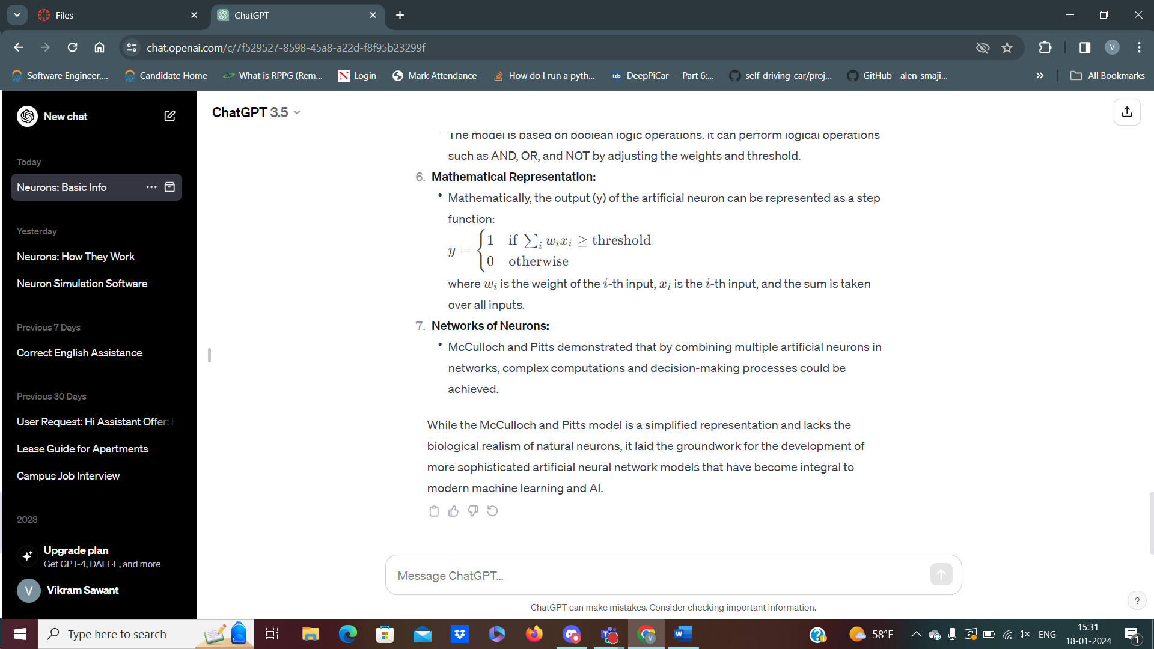

1. **Networks of Neurons:**

McCulloch and Pitts demonstrated that by combining multiple artificial neurons in networks, complex computations and decision-making processes could be achieved.